**Answering Audio Surveys - Android**

**\*Images and menus may look slightly different depending on which smart phone you are using. If you have any questions on how to complete your audio text message please feel free to call us at 890-4796.**

You will receive one message prompt per day asking you to send an audio message. The prompt will look similar to the message below:

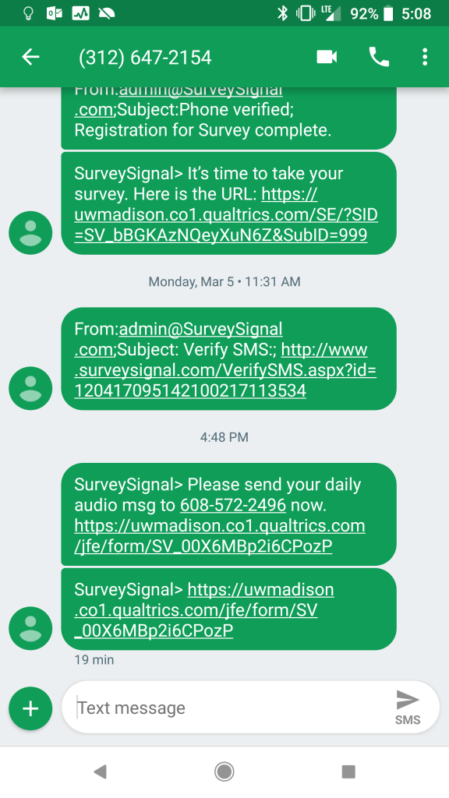

1. Save the phone number (608-572-2496) in your Contacts under a title that you will remember (we suggest labeling it Audio Survey)

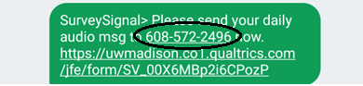

1. When you are ready to send your audio survey click on the **Messages** icon and click the Compose message icon 

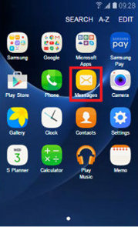 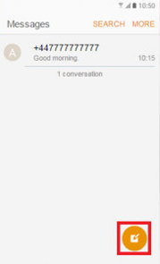

1. Click on the paperclip icon or the plus sign (depending on the Android model)

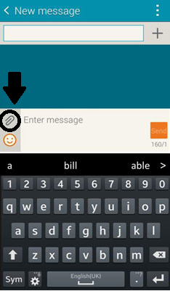 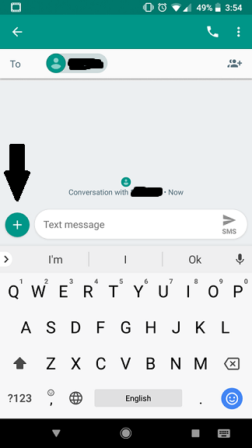

1. Select Record Audio

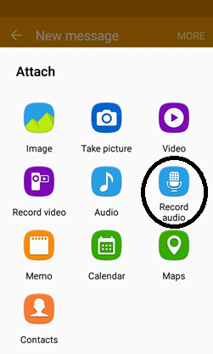

1. Your audio message needs to be between 15-30 seconds long. Press the red circle to start recording

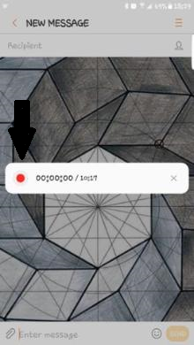

1. Alternatively, there may be an icon similar to the one below that will be to the right of the text message box on some Android phones. To record a message you click on the sound wave icon which will be located to the right of the text message box.

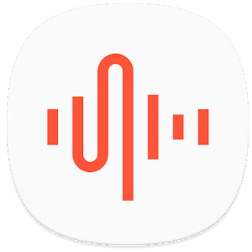

1. If you are satisfied with your message you can send it just like you would any other text message. (Remember to send the message after recording)
2. Your message will look something like this when it is sent

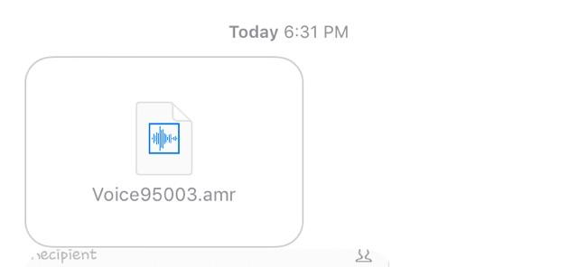

**Additional written instructions:**